**Muhammad Ali Jinnah University**

**Karachi, Pakistan**



**DATA STRUCTURE & ALGORITHM**

**PROJECT NAME: HOSTEL MANAGEMENT SYSTEM**

**Name: Syed Mustafa Hassan & Muhammad Noman**

**Student ID: FA21-BSCS-0030 & FA21-BSCS-0032**

**Section: AM**

**Batch: FA21**

***SUBMITTED TO: Miss Anum Jawed***

Software Requirements Specification for Hostel Management System

Introduction :

Purpose of this document:

The purpose of this SRS document is to provide a detailed overview of our Software Requirements

Specification for Hostel Management System, its parameters, and goals. This document describes the

project's target audience, user interface, hardware, and software requirements. It defines how our

client, team, and audience see the product and its functionality.

Software Requirements Specification for Hostel Management System

Introduction :

Purpose of this document:

The purpose of this SRS document is to provide a detailed overview of our Software Requirements

Specification for Hostel Management System, its parameters, and goals. This document describes the

project's target audience, user interface, hardware, and software requirements. It defines how our

client, team, and audience see the product and its functionality

Software Requirements Specification for Hostel Management System

Introduction :

Purpose of this document:

The purpose of this SRS document is to provide a detailed overview of our Software Requirements

Specification for Hostel Management System, its parameters, and goals. This document describes the

project's target audience, user interface, hardware, and software requirements. It defines how our

client, team, and audience see the product and its functionality.

**Software Requirements Specification (SRS) Document for MAJU Hostel Management System**

**ABSTRACT**

This is a design and implementation of an online Hostel Management System. “ONLINE HOSTEL MANAGEMENT SYSTEM” is a software developed for managing various activities in the hostel. For the past few years, the number of educational institutions is increasing rapidly. Thereby the number of hostels is also increasing for the accommodation of the students studying in this institution. And hence there is a lot of strain on the person who is running the hostel and software’s not usually used in this context. This particular project deals with the problems of managing a hostel and avoids the problems which occur when carried out manually. Identification of the drawbacks of the existing system leads to the designing of a computerized system that will be compatible with the existing system with the system which is more user-friendly and more GUI-oriented. We can improve the efficiency of the system, thus overcoming the drawbacks of the existing system.

**I. INTRODUCTION**

**“HOSTEL MANAGEMENT SYSTEM” is a software developed for managing various activities in the hostel. For the past few years, the number of educational institutions are increasing rapidly. Thereby the number of hostels is also increasing for the accommodation of the students studying in the institution. The particular project deals with the problems of managing a hostel and avoids the problems which occur when carried out manually. In the system, we can easily manage hostel details, room details, student records, mess expenditure, mess bill calculation, easy way of room allocation, and hostel attendance. We can improve the efficiency of the system.**

1. **Objectives**

The main objective of the Hostel Management System is to manage the details of Rent, Allotters, Hostel, Rooms, and Payments. It manages all the information about Rent, Beds, and Payments, and the project aims project is to build an application program to reduce the manual work of managing Rent, Allotters, Beds, and Hostel. It tracks all the details about the Hostel, Rooms, and Payments.

1. Provides the search facilities based on various factors. Such as Rent, Hostel, Rooms, and Payments.
2. College Management System also sells employee details online for student details, employees’ details, and courses.
3. College Management System also sells employee details online for student details, employees’ details, and courses.
4. Provide the functionality to make your bookings
5. Update without the need to get a web designer involved.
6. It tracks all the information of Allottees, Beds, Rooms, etc.
7. Manage the information of Allottees.
8. Shows the information and description of the Rent, Hostel
9. To increase the efficiency of managing the Rent, Allottees.

10. It deals with monitoring the information & transactions of Rooms.

11. Manage the information on Rent.

**II. PROBLEM DEFINITION**

There are a lot of drawbacks to keeping and maintaining a hostel. Especially with a manual system. Since most hostels are run by only one hostel manager, the number of students in a room is sometimes not known by the officer. He has to go room by room to ensure that a room is occupied or not. Sometimes people may be owing in the hostel and they are saved on papers or huge notebooks, and sometimes receipts. If the books should go missing or stolen, one would never be able to know if a student is owed or not. Room allocation also becomes a problem as the officer might not know which rooms are available or not. And some hostels have a lot of rooms or have mare stories and it would be very tedious to go through all stories in search of a free room for an applicant. Also, the officer might not know the number of students in a room or know if a room is full or not.

1. **Existing System**

The existing system is manual-based and needs a lot of effort and consumes enough time. In the existing system, we can apply for the hostels online but the allotment processes are done manually. It may lead to corruption in the allocation process as well as hostel fee calculation. The existing system does not deal with mess calculation and complaint registration.

1. ***Proposed System***

This project is aimed at developing a system for keeping records and showing information about or in a hostel. This system will help the hostel officer to be able to manage the affairs of the hostel. This system will provide full information about a student in the hostel. It will show rooms available on r not and the number of people in a particular room. There will also be an administrator module that will be accessed by the administrator and can delete, add and edit employee records. This system will be developed based on Software Development Life Cycle (SDLC) with a C++ server. C++ is good for the development and design of web-based programs whiles DSA is good for databases because of its security and its advanced features and properties.

**III. REQUIREMENT ANALYSIS**

***A. Functional Requirements***

1. User shall generate the user’s profile containing the following information user’s account no, full name, address, phone no & room no.
2. User will change dues status in a database according to whether dues are paid or not.
3. User must allow the warden to add new users to the system’s database.
4. User must allow the guardian to cancel the registration from the system’s database who will leave rooms.

***B. Non-Functional Requirements***

1. The system should be reliable. It should always be up and running.
2. The system should have high performance.
3. Less human error.
4. Strength and strain of manual labor can be reduced
5. High security ·

**C. Hardware Requirements**

The section on hardware configuration is an important task related to software development. Insufficient random access m adversely affects the entire system's speed inefficiency system. The process should be powerful to handle the entire operation. The hard disk should have sufficient capacity to store the file and application.

**D. Software Configuration**

A major element in building a system is the section of compatible software since the software in the market is experiencing geometric progression. Selected software should be acceptable by the firm and one user as well as it should be feasible for the system.

**Technology Implemented:**

1. OBJECT-ORIENTED PROGRAMMING:

* Class’s & Object
* Inheritance
* Encapsulation
* Friend Function
* Friend Class
* Static Data Member
* Static Data Function
* Inline Function
* Constructors
* Destructor
* File Handling
* Setter
* Header Files
* Getter
* Keywords
* New
* Delete
* Constant
* Type-def
* Goto

1. DATA STRUCTURE & ALGORITHM:

* Manage Time Complexity
* Manage Space Complexity
* Array Data Structure
* Queue Data Structure
* Singly Linked List Data Structure
* Doubly Linked List Data Structure
* Stack using Linked List
* Queue using Linked List
* Recursion
* Insertion sort
* Quick Sort

**IV. SYSTEM DIAGRAM**

* 1. ***Use-Case Diagram***

This Use Case Diagram is a graphic depiction of the interactions among the elements of the Hostel Management System. It represents the methodology" used in system analysis to identify, clarify, and organize system requirements of Hostel Management System.

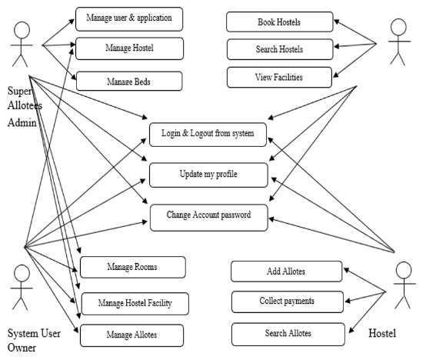

* 1. ***Sequence Diagram***

This is the Sequence Diagram of the Hostel Management System, where admin will be able to login into their account using their credentials. After login user can manage all the operations on Hostel, Rooms, Allottees, Payments, and Rent.

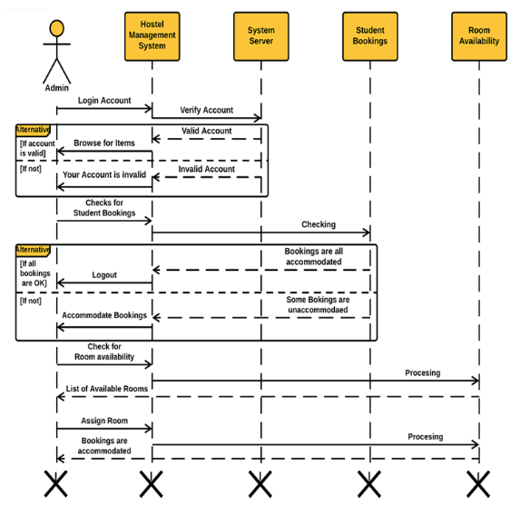

##### Conclusion

To conclude the description of the project, the project, developed using C++ with OOP & DSA is based on the requirement specification of the user and the analysis of the existing system, with flexibility for future enhancement. HOSTEL MANAGEMENT SYSTEM is very useful for hostel allotment and mess fee calculation This hostel management software is designed for people who want to manage various activities in the hostel.